EDA project –
Product Sale & Profit Dashboard
By Monika kumari

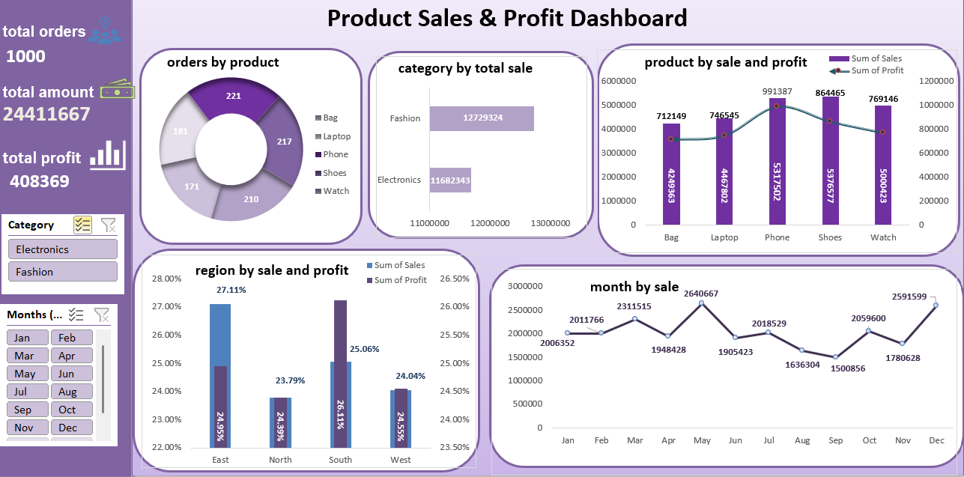

1.KPI cards
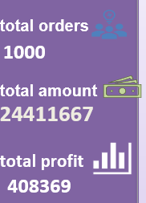
-total orders 1000
-overall total revenue 24411667
-overall total profit 408369
2.using Slicer
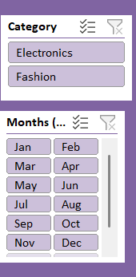
This is category and months slicer. filter all the chart accordingly you which choose the option.
3.order by product
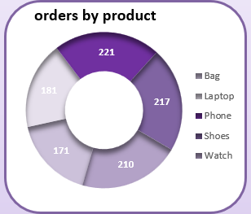
Using pie chart show the all order by product. Phone achieve high order and very low order in laptop product.
4.category by total sale
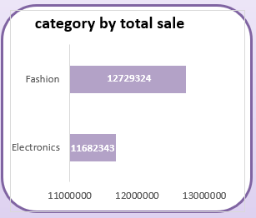
Using bar chat show overall revenue by category. fashion high revenue generated.
5.product by sales & profit
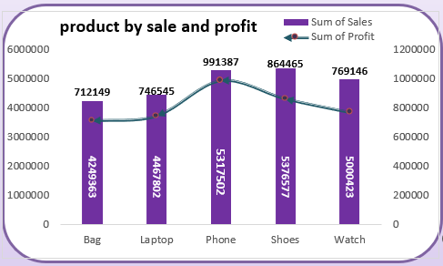
Using combo chart show sale and profit by product. Shoes is most Selling product but phone is most profitable product.

6. regions by sales & profit
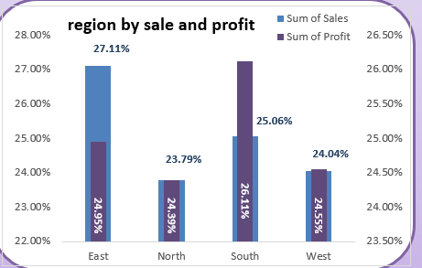
Using also combo chart in regions by sales and profit. accordingly sales east is the most selling region but accordingly profit south region is most profitable region.

7.months by sales
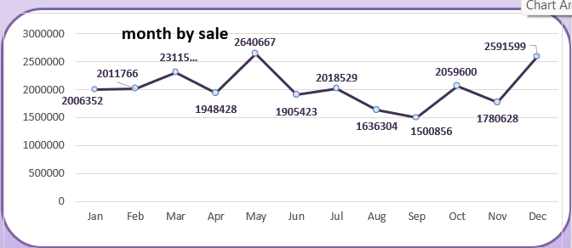
Using line chart in months by sales. may is the highest selling month and then December. September is very low selling months.

Conclusion
-overall total revenue 24411667
-overall total profit 408369
-most demanding product is phone.
-Most high revenue generated is fashion category.
-most selling product is shoes but profitable product is phone.
-most selling region is east but profitable region is south.

